F-28 -

Functionality
This transaction allows you to post customers’ incoming payments and at the same time process open items. Usually you post payment and clear it with outstanding invoice/s.

Scenario
The customer’s paid for an outstanding invoice. You want to clear the customer invoice against the payment.

Requirements
Outstanding customer invoices or other open items to be cleared by a payment

Menu Path | Financial Accounting → Accounts Receivable → Document entry → Incoming payment
Transaction Code | F-28

1. Double click on F-28 Incoming payment.

Post Incoming Payments: Header Data

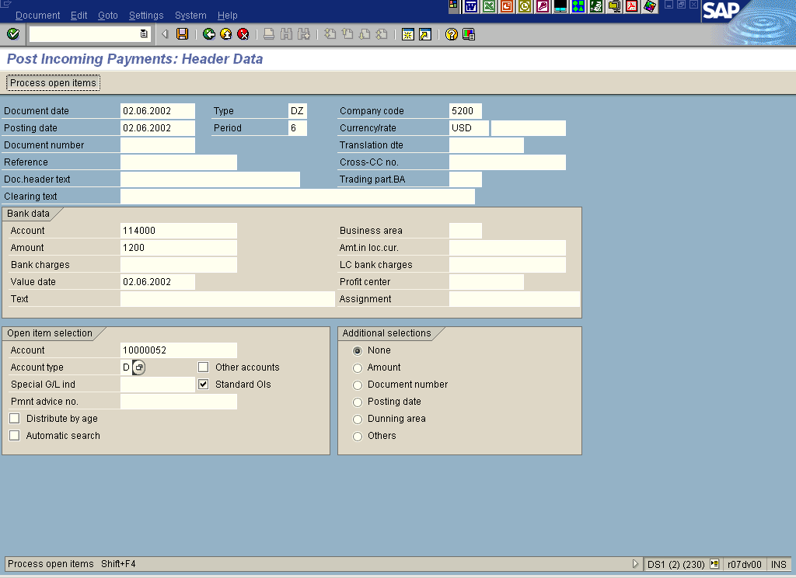

2. Update the following fields:

Field Name | Field Description | Values
Document date | Date the transaction occurred | Example: 02.06.2002
Type | Code identifying the document type | Example: DZ
Company code | Your company code number | Example: 5200
Posting date | Date that the business transaction occurred | Example: 02.06.2002
Currency/rate | Code identifying the currency used in the transaction | Example: USD
Account | Code identifying the Bank account | Example: 114000
Amount | Amount of the line item (payment) | Example: 1200
Account | Code identifying the Customer account | Example: 10000052
Account type | Define the type of the account:  D – Customers,  K – Vendors,  S – GL Account | Example: D

3. Click Process open items Button . The system will display a screen where you can clear your incoming payment with the outstanding invoices.

Post Incoming Payments: Process open items

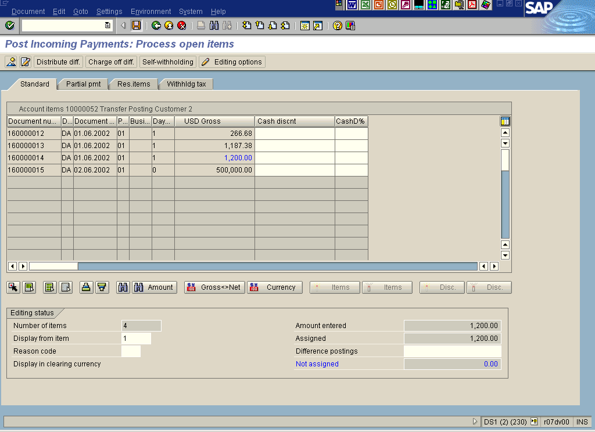

All open items are selected. You need first to deselect them:
4. Click Select all Button .

5. Click Items Button to deactivate all the items.

6. Click on the item you want to clear with payment (customer document 160000014)

7. The value of “Not assigned” field is equal 0, so you can save your transaction. Click Save Button..

8. The message bar displays “Document XXXXXX was posted in company code 5200”.

